**Exercise 1: Parameterized Tests**

**EvenChecker.java:**

package com.example.junit;

public class EvenChecker

{

public boolean isEven(int n){

return n % 2 == 0;

}

}

**EvenCheckerTest.java:**

package com.example.junit;

import static org.junit.jupiter.api.Assertions.assertFalse;

import static org.junit.jupiter.api.Assertions.assertTrue;

import org.junit.jupiter.params.ParameterizedTest;

import org.junit.jupiter.params.provider.ValueSource;

public class EvenCheckerTest {

EvenChecker c = new EvenChecker();

@ParameterizedTest

@ValueSource(ints = {2, 4, 6, 8, 10})

void testEvenNumbers(int n) {

assertTrue(c.isEven(n), n + " should be even");

}

@ParameterizedTest

@ValueSource(ints = {1, 3, 5, 7, 9})

void testOddNumbers(int n) {

assertFalse(c.isEven(n), n + " should be odd");

}

}

**Output:**

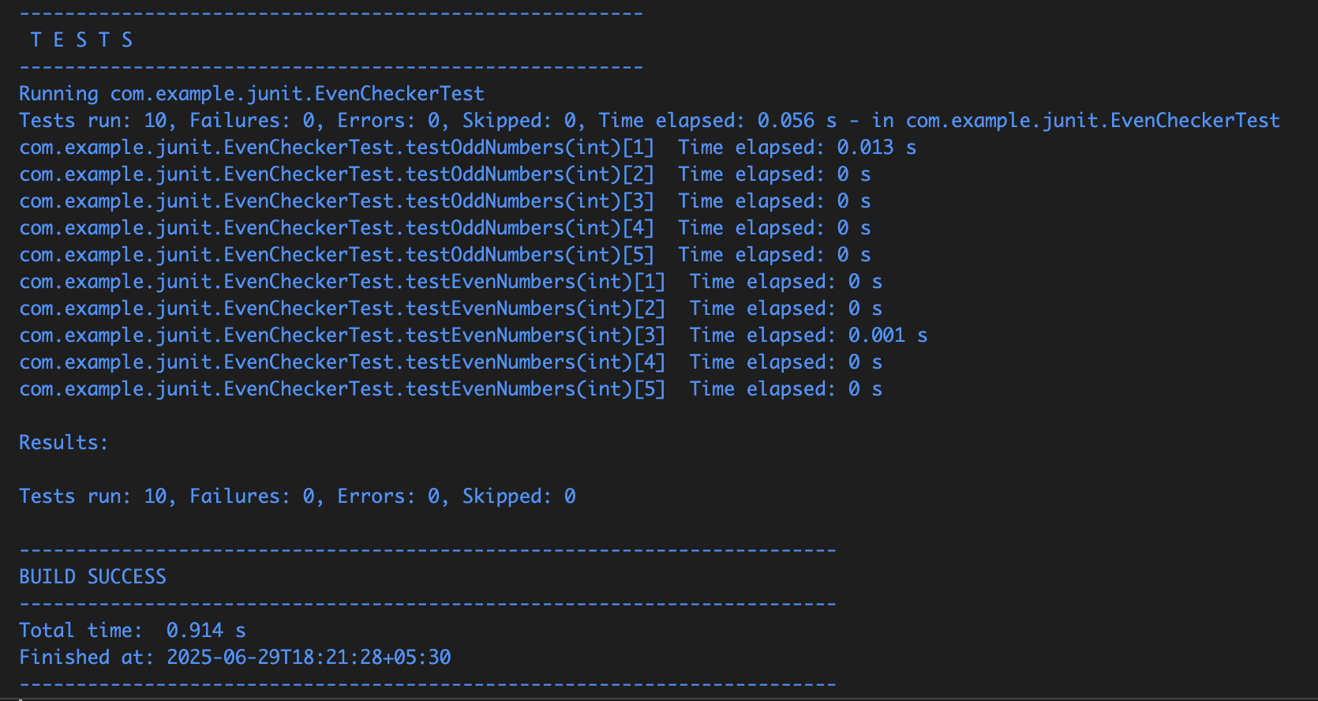

**Exercise 2: Test Suites and Categories**

**Test1.java:**

package com.example.junit;

import static org.junit.jupiter.api.Assertions.assertEquals;

import org.junit.jupiter.api.Test;

public class Test1 {

@Test

void testAddition() {

assertEquals(5, 2 + 3, "2 + 3 should be 5");

}

}

**Test2.java:**

package com.example.junit;

import static org.junit.jupiter.api.Assertions.assertTrue;

import org.junit.jupiter.api.Test;

public class Test2 {

@Test

void testString() {

assertTrue("JUnit".startsWith("J"), "String should start with 'J'");

}

}

**AllTests.java:**

package com.example.junit;

import org.junit.platform.suite.api.SelectClasses;

import org.junit.platform.suite.api.Suite;

@Suite

@SelectClasses({ Test1.class, Test2.class })

public class AllTests {

}

**Output:**

Test1 output:

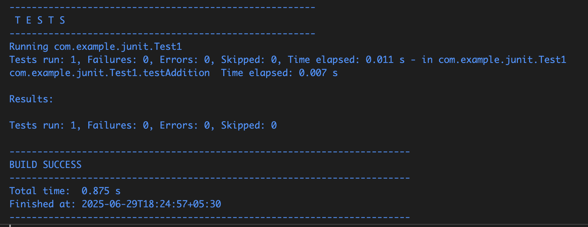

Test2 output:

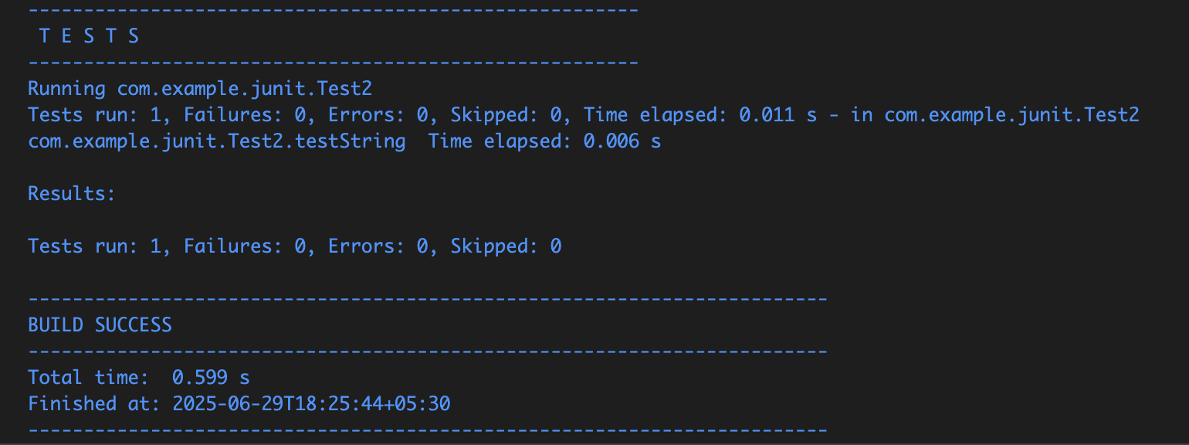

Since I don’t have MAVEN installed locally, i tried to run the AllTests code

It showed no error, and Test1 and Test2 were running perfectly. Output was not seen due to no Maven installation.

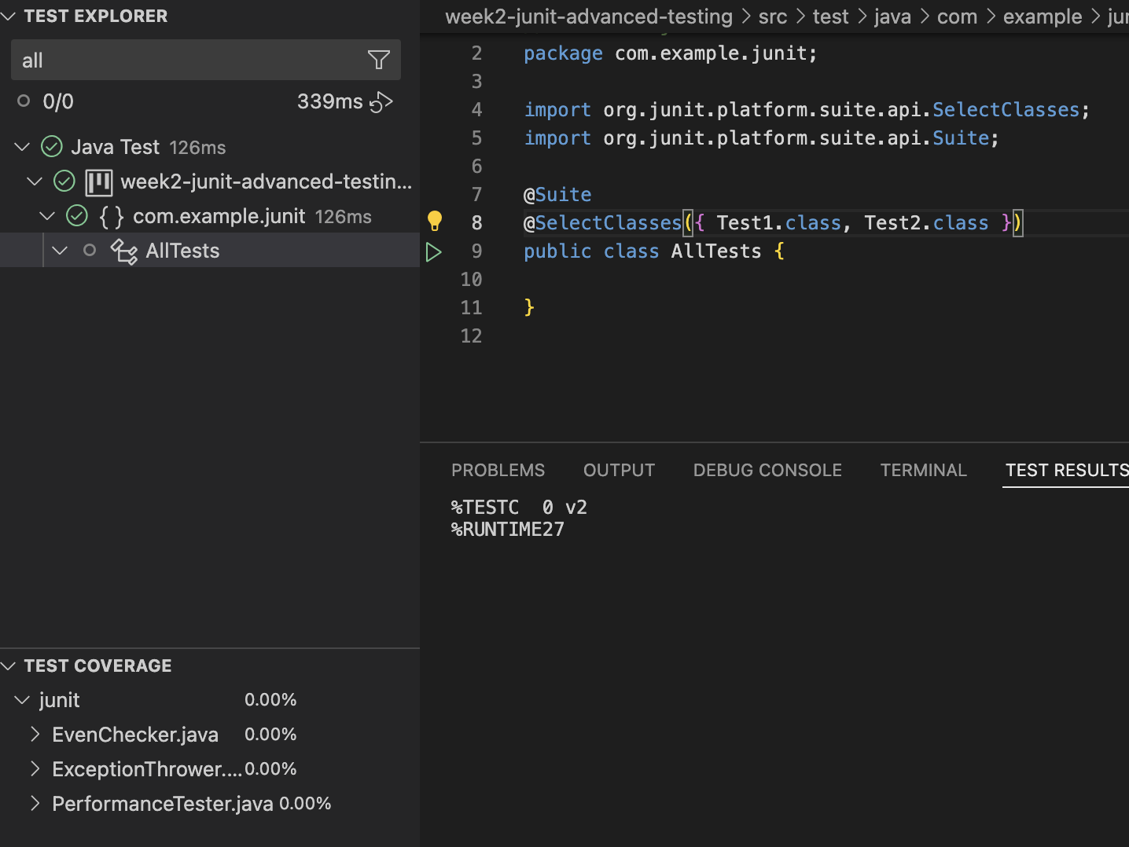

**Exercise 3: Test Execution Order**

**OrderedTests.java:**

package com.example.junit;

import static org.junit.jupiter.api.Assertions.assertEquals;

import static org.junit.jupiter.api.Assertions.assertNotNull;

import static org.junit.jupiter.api.Assertions.assertTrue;

import org.junit.jupiter.api.MethodOrderer;

import org.junit.jupiter.api.Order;

import org.junit.jupiter.api.Test;

import org.junit.jupiter.api.TestMethodOrder;

@TestMethodOrder(MethodOrderer.OrderAnnotation.class)

public class OrderedTests {

@Test

@Order(3)

void testC() {

System.out.println("Running testC");

assertTrue(5 > 3);

}

@Test

@Order(1)

void testA() {

System.out.println("Running testA");

assertEquals(2, 1 + 1);

}

@Test

@Order(2)

void testB() {

System.out.println("Running testB");

assertNotNull("Hello");

}

}

**Output:**

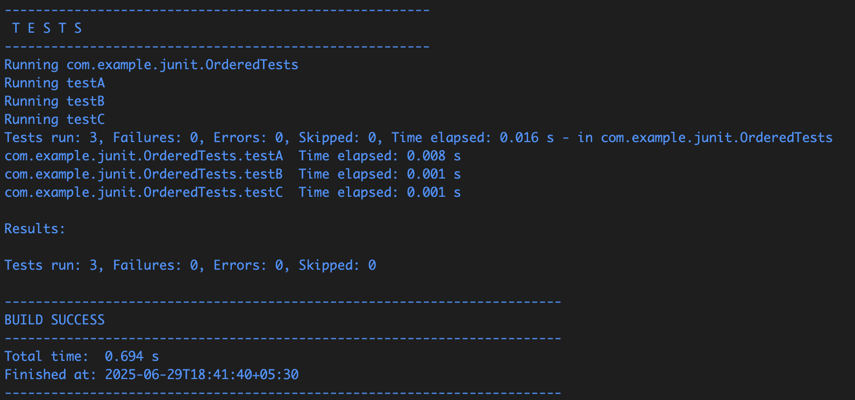

**Exercise 4: Exception Testing**

**ExceptionThrower.java:**

package com.example.junit;

public class ExceptionThrower {

public void throwException(String s) {

if (s == null)

{

throw new IllegalArgumentException("Input cannot be null");

}

}

}

**ExceptionThrowerTest.java:**

package com.example.junit;

import static org.junit.jupiter.api.Assertions.assertDoesNotThrow;

import static org.junit.jupiter.api.Assertions.assertEquals;

import static org.junit.jupiter.api.Assertions.assertThrows;

import org.junit.jupiter.api.Test;

public class ExceptionThrowerTest {

ExceptionThrower t = new ExceptionThrower();

@Test

void testExceptionThrown() {

System.out.println("Running testExceptionThrown");

Exception e = assertThrows(IllegalArgumentException.class, () -> {

t.throwException(null);

});

assertEquals("Input cannot be null", e.getMessage());

}

@Test

void testNoException() {

System.out.println("Running testNoException");

assertDoesNotThrow(() -> {

t.throwException("valid input");

});

}

}

**Output:**

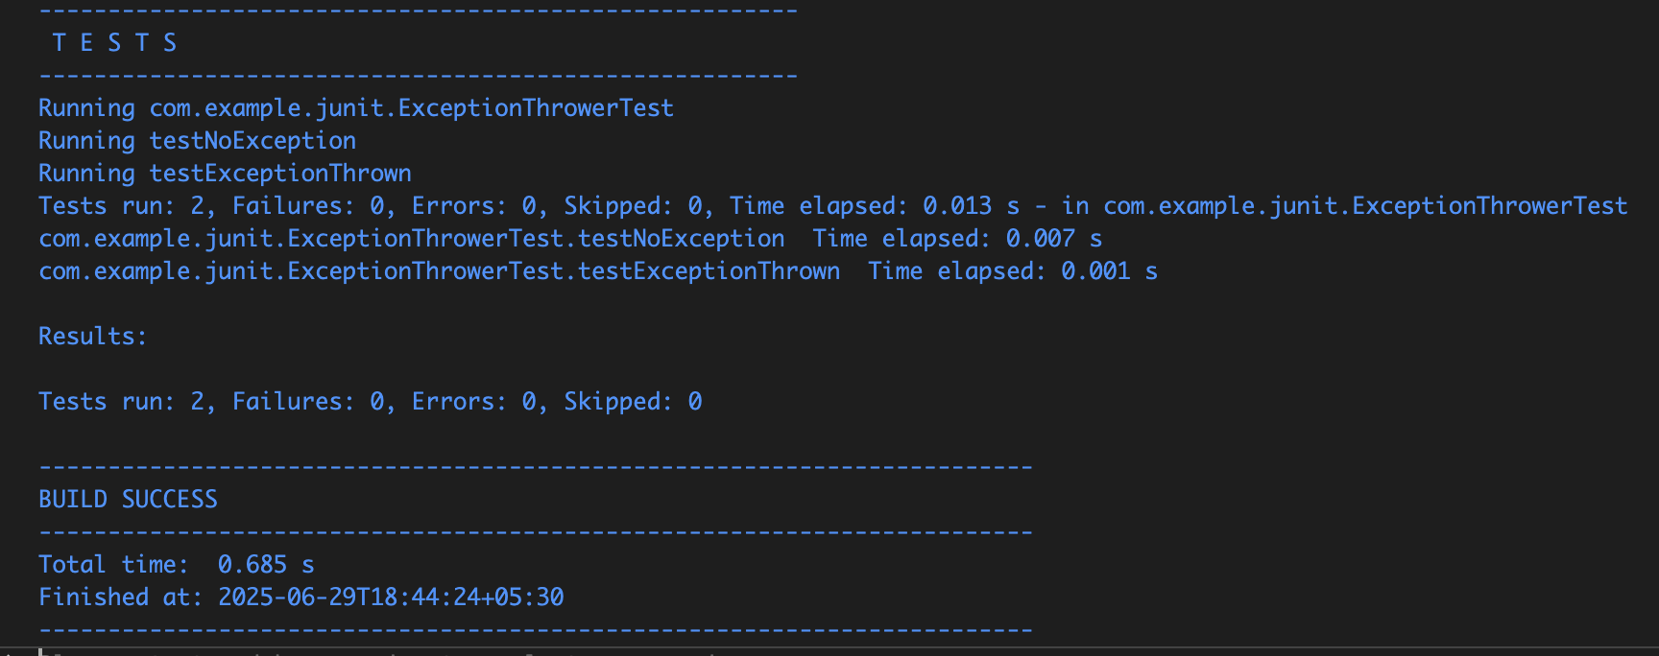

**Exercise 5: Timeout and Performance Testing**

**PerformanceTester.java:**

package com.example.junit;

public class PerformanceTester {

public void performTask() {

try {

Thread.sleep(100);

} catch (InterruptedException e) {

Thread.currentThread().interrupt();

}

}

}

**PerformanceTesterTest.java:**

package com.example.junit;

import java.time.Duration;

import static org.junit.jupiter.api.Assertions.assertTimeout;

import org.junit.jupiter.api.Test;

public class PerformanceTesterTest {

PerformanceTester tester = new PerformanceTester();

@Test

void testTaskCompletesWithinTimeout() {

System.out.println("Running testTaskCompletesWithinTimeout");

assertTimeout(Duration.ofMillis(500), () -> tester.performTask());

}

}

**Output:**

